**WEEK-2**

**Exercise 4: Arrange-Act-Assert (AAA) Pattern, Test Fixtures, Setup and**

**Teardown Methods in Junit**

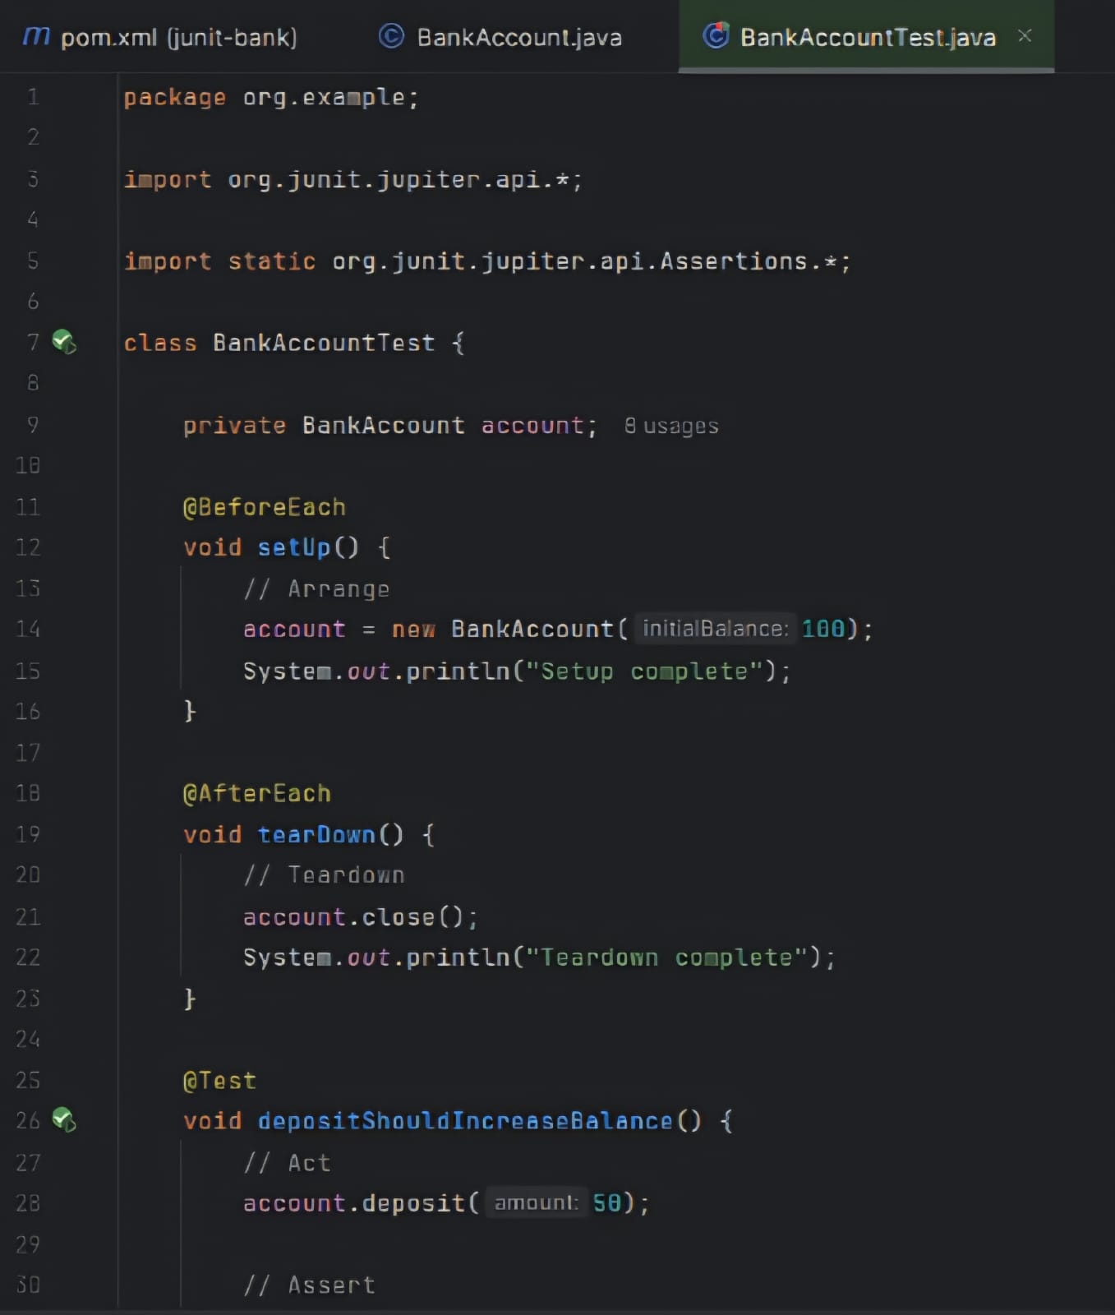

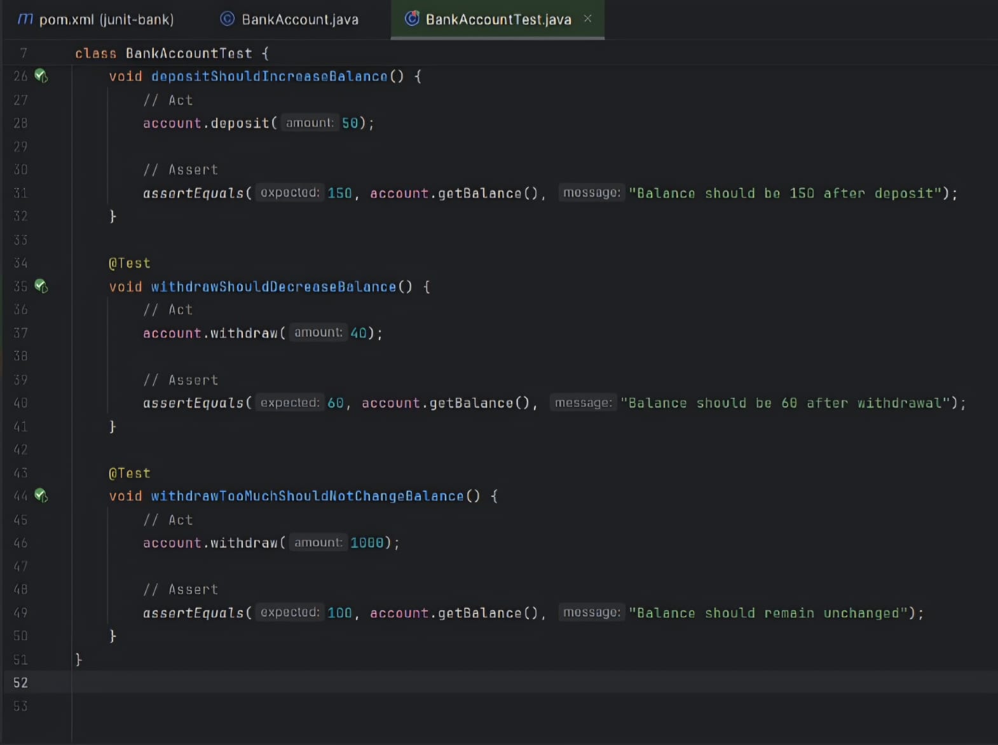

OUTPUT:

